Contents

Instructor View Page 2

Instructor Course Page View 3

Instructor Add Course View 4

Instructor Remove Course View 5

Instructor Student View 6

Instructor – Track a Student View 7

Instructor – Mark Attendance View 8

Instructor – Login/Logout Page 9

Student- Home Page, Login Page 10

Student- Reset Password 11

Student – Setting a New Password 12

Student- Signup Page, Scan and Capture QR code Page 13

Student – Scan and Capture Feedback, Courses Page. 14

Student – View Course Details View, Attendance View. 15

Instructor Prototypes

Instructor View Page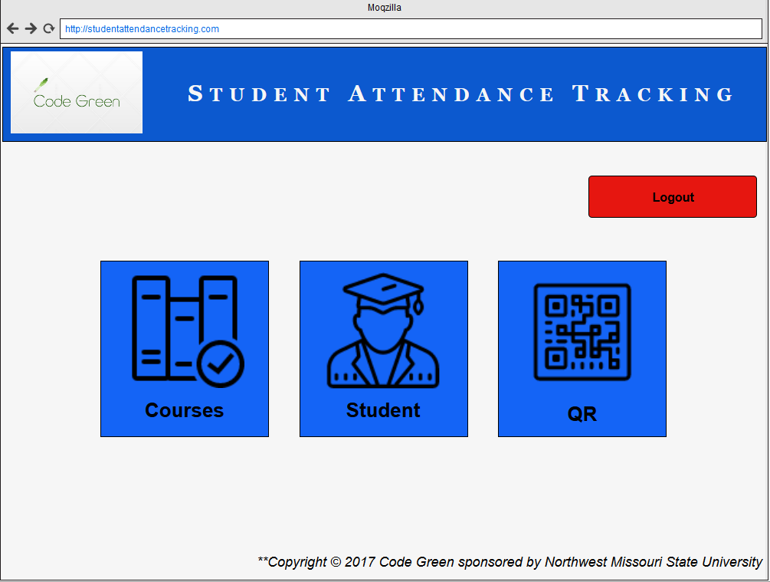

## Instructor Course Page View

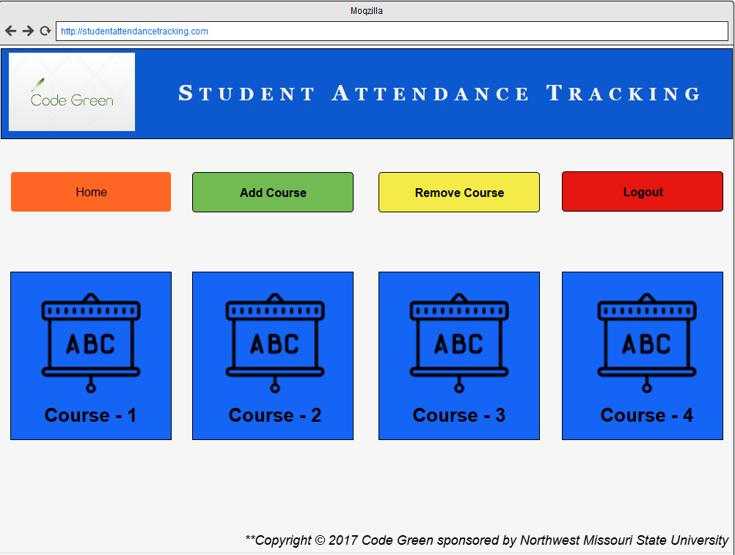

## Instructor Add Course View

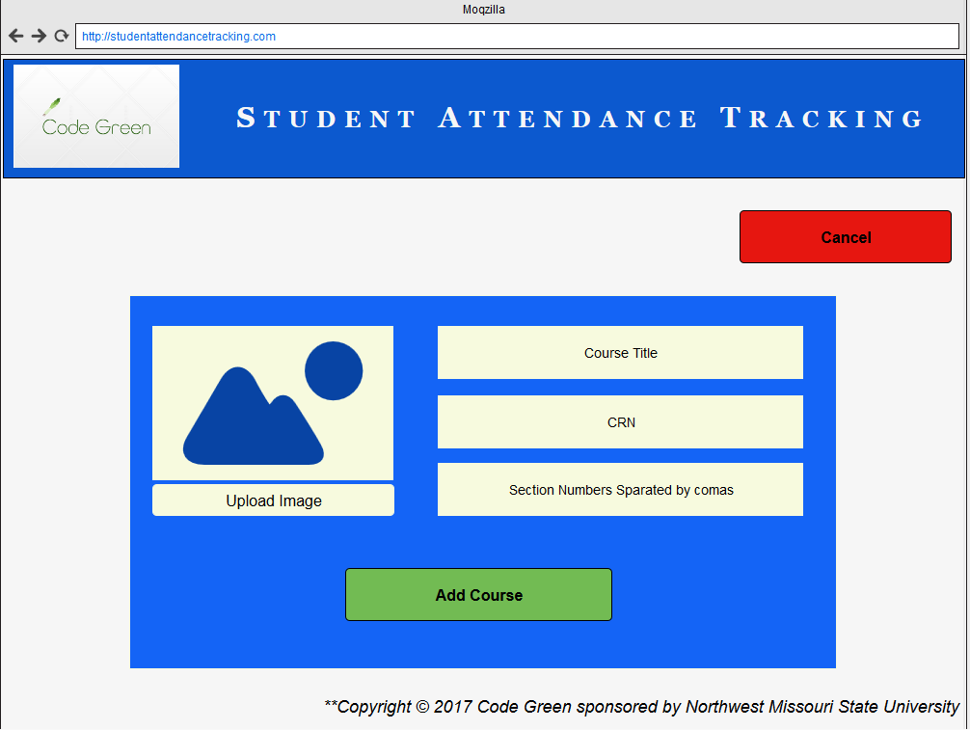

## Instructor Remove Course View

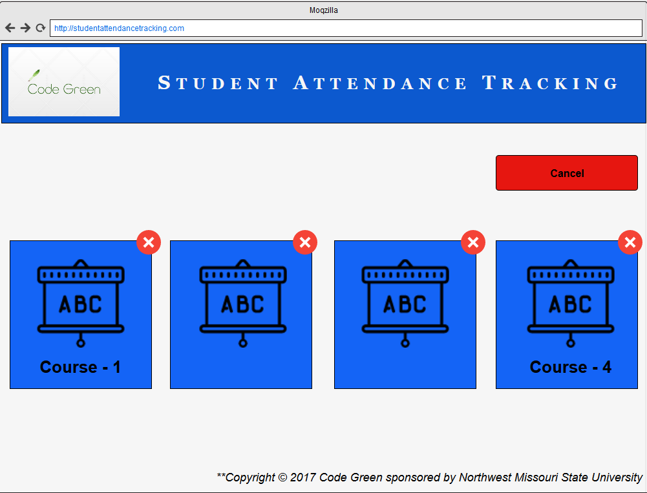

## Instructor Student View

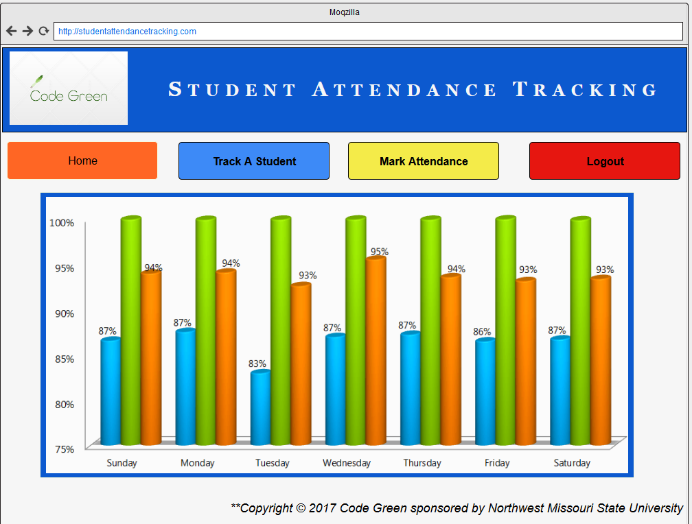

## Instructor – Track a Student View

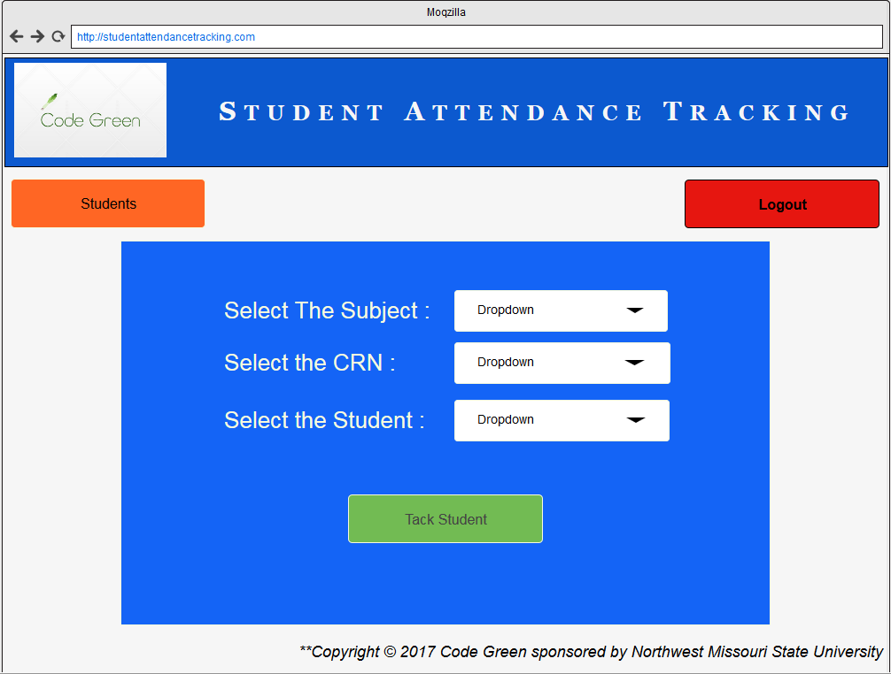

## Instructor – Mark Attendance View

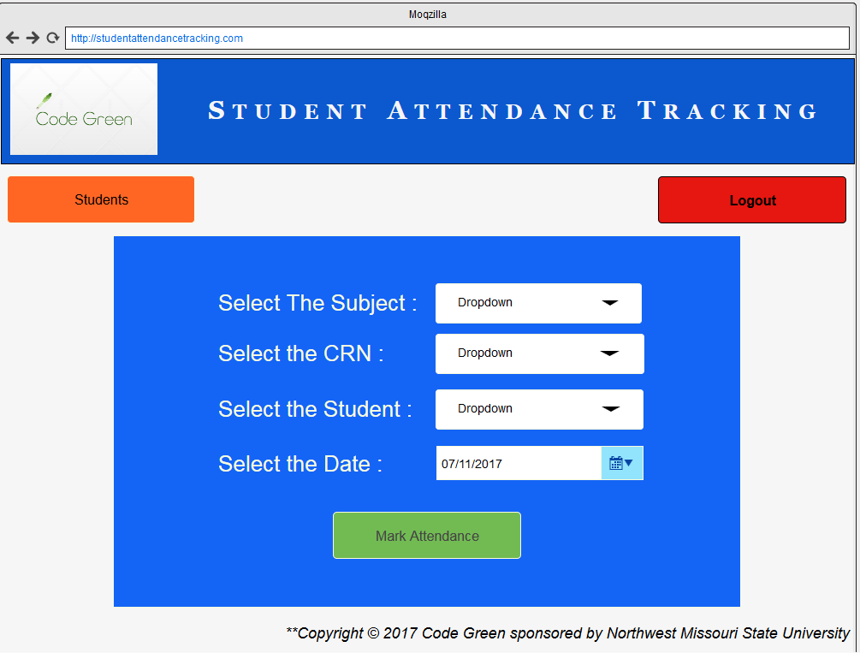

## Instructor – Login/Logout Page

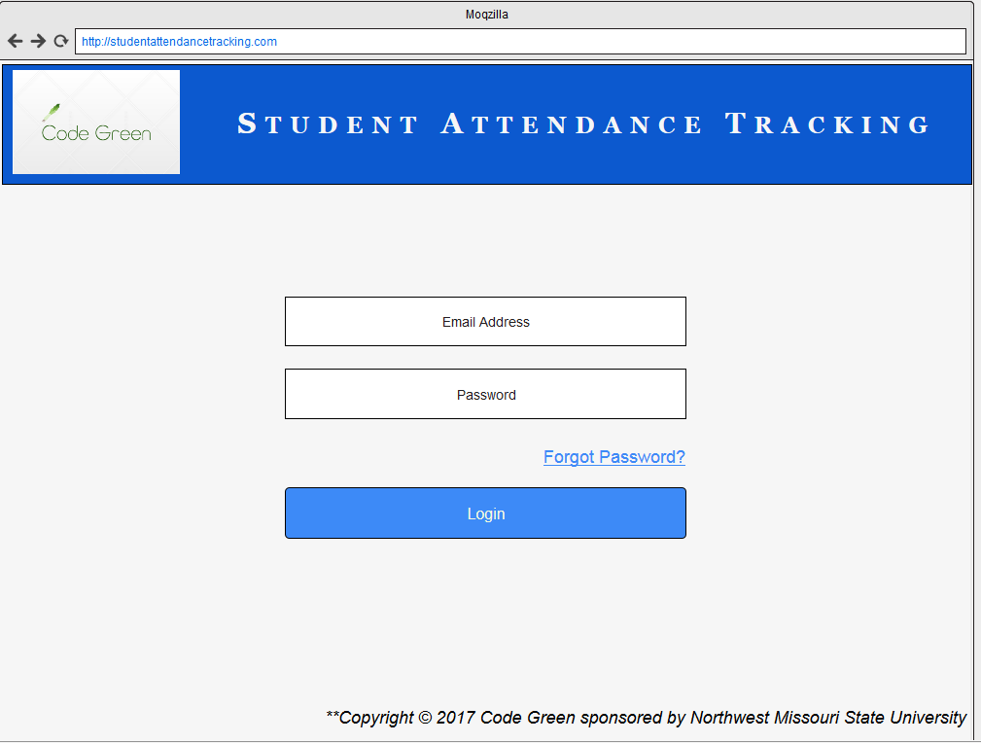

Student Prototypes

## Student- Home Page, Login Page

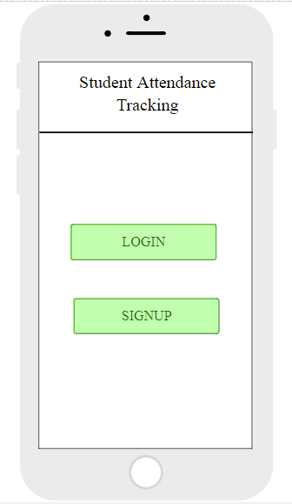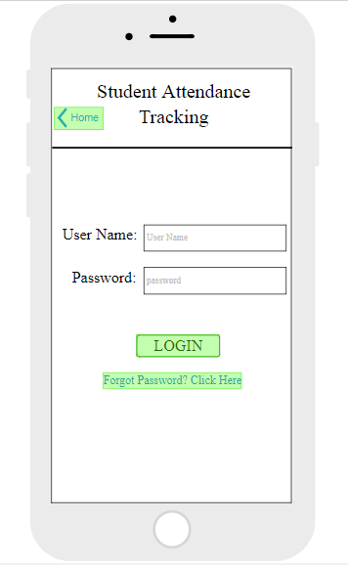

## Student- Reset Password

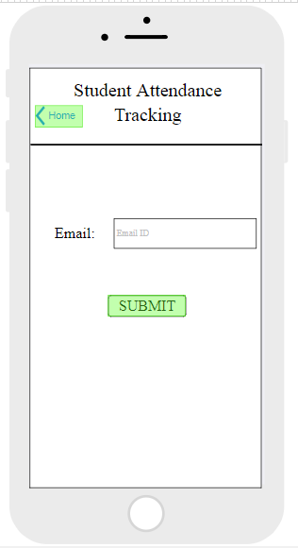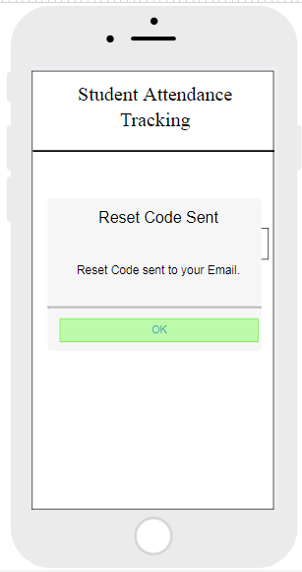

## Student – Setting a New Password

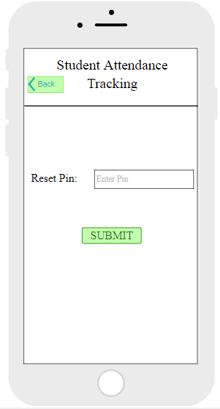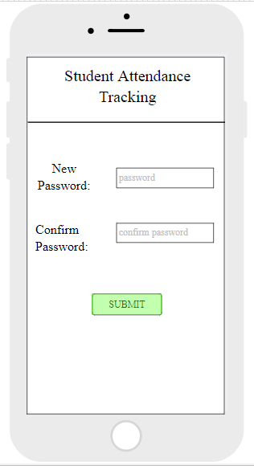

## Student- Signup Page, Scan and Capture QR code Page

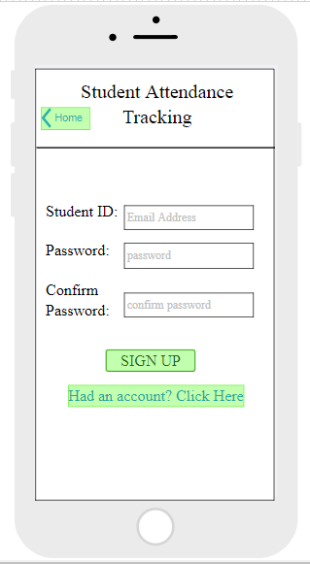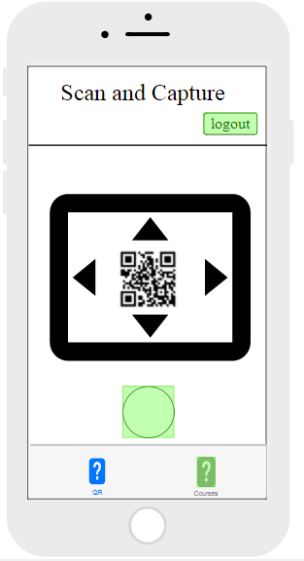

## Student – Scan and Capture Feedback, Courses Page.

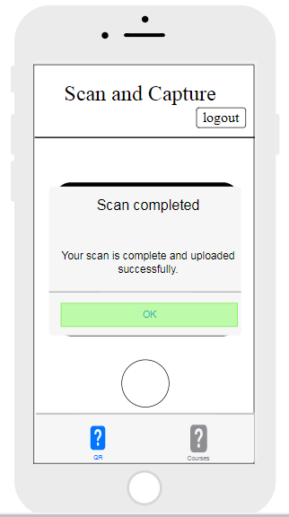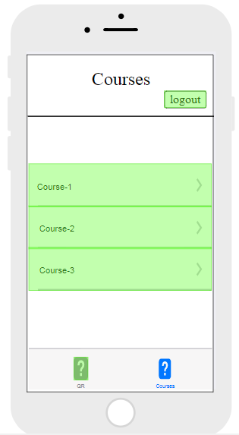

## Student – View Course Details View, Attendance View.

